Experiment 1: Image Reading and Grayscale Conversion
Aim: To read an input image using Python OpenCV and convert it into a grayscale image.
Procedure
- Import the OpenCV library (cv2) in Python.
- Specify the file path of the input image.
- Read the image into memory using the cv2.imread() function.
- Convert the color image (BGR) to grayscale using cv2.cvtColor() with cv2.COLOR_BGR2GRAY.
- Display both the original and grayscale images using cv2.imshow().
- Hold the display windows with cv2.waitKey(0) and clean up resources using cv2.destroyAllWindows().
Code
import cv2
img = cv2.imread(r"C:\Users\acer\Downloads\pretty lotus.jpeg")
gray = cv2.cvtColor(img, cv2.COLOR_BGR2GRAY)
cv2.imshow("Original Image", img)
cv2.imshow("Grayscale Image", gray)
cv2.waitKey(0)
cv2.destroyAllWindows()
Input
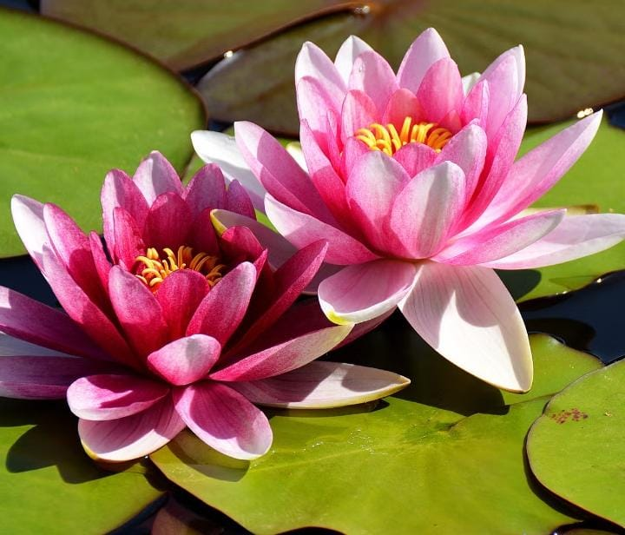

Output
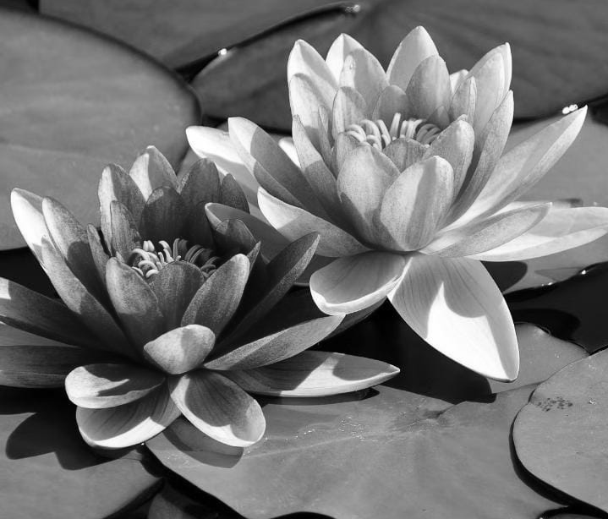
Result: The input color image was successfully read and converted into a grayscale image using Python and OpenCV.

Experiment 2: Image Blurring using Gaussian Blur
Aim: To read an input image using Python OpenCV and apply Gaussian Blur to smooth the image.
Procedure
- Import the required cv2 library.
- Define the path location of the image file.
- Read the image from the specified path using cv2.imread().
- Apply the Gaussian Blur filter using cv2.GaussianBlur() with a designated kernel size (e.g., $7×7$).
- Display the original image and the blurred output image using cv2.imshow().
- Close all active windows on user input using cv2.destroyAllWindows().
Code
import cv2
img = cv2.imread(r"C:\Users\acer\Downloads\pretty lotus.jpeg")
blur = cv2.GaussianBlur(img, (7, 7), 0)
cv2.imshow("Original Image", img)
cv2.imshow("Blurred Image", blur)
cv2.waitKey(0)
cv2.destroyAllWindows()

Input

Output
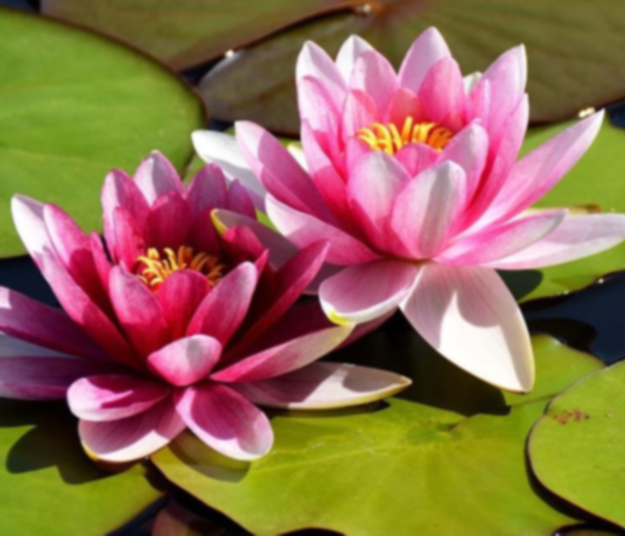
Result: The input image was successfully loaded and converted into a smoothed/blurred image using the Gaussian Blur function.

Experiment 3: Edge Detection using Canny Function
Aim: To read an input image using Python OpenCV and extract its structural outline using the Canny edge detection function.
Procedure
- Import the OpenCV package (cv2).
- Provide the absolute file path of the source image.
- Read the input image using cv2.imread().
- Convert the color image to grayscale to simplify gradient processing.
- Pass the grayscale image through cv2.Canny() with lower and upper hysteresis thresholds.
- Display the detected outline/edge map and destroy windows after key press.
Code
import cv2
img = cv2.imread(r"C:\Users\acer\Downloads\pretty lotus.jpeg")
gray = cv2.cvtColor(img, cv2.COLOR_BGR2GRAY)
edges = cv2.Canny(gray, 100, 200)
cv2.imshow("Original Image", img)
cv2.imshow("Canny Edges", edges)
cv2.waitKey(0)
cv2.destroyAllWindows()
Input

Output
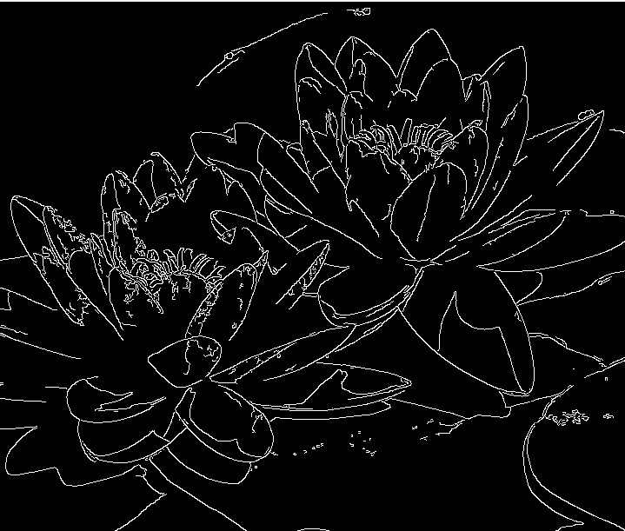
Result: The image outline and prominent edges were successfully extracted and displayed using the Canny edge detection algorithm.

Experiment 4: Histogram Equalization
Aim: To perform histogram equalization on an input image using OpenCV and compare it with the original image.
Procedure
- Import cv2 and numpy modules.
- Specify the image path and read the image directly in grayscale mode (cv2.imread(path, 0)).
- Apply cv2.equalizeHist() on the grayscale image array to adjust global contrast.
- Concatenate the original and equalized images horizontally using np.hstack().
- Display the side-by-side comparison window using cv2.imshow().
- Release window resources upon pressing any key.
Code
import cv2
import numpy as np
img = cv2.imread(r"C:\Users\acer\Downloads\pretty lotus.jpeg", 0)
equ = cv2.equalizeHist(img)
res = np.hstack((img, equ))
cv2.imshow("Original vs Equalized", res)
cv2.waitKey(0)
cv2.destroyAllWindows()
Input

Output
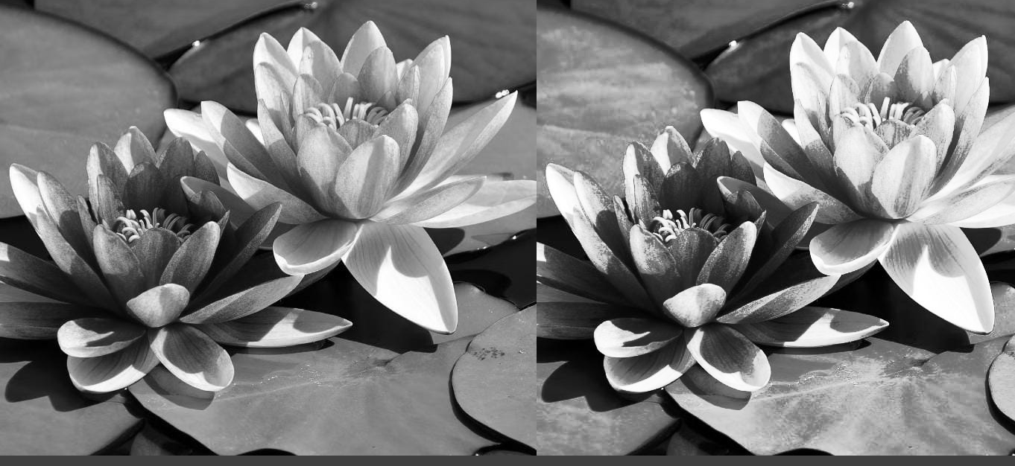
Result: Histogram equalization was successfully applied to enhance the contrast of the original image, and a comparative output was generated.

Experiment 5: Color Level Histogram Analysis
Aim: To write a Python function that analyzes and plots the histogram of an input image across its individual color channels using OpenCV.
Procedure
- Import cv2 and matplotlib.pyplot packages.
- Create a custom Python function that accepts the image path as an argument.
- Read the image and define a list corresponding to BGR color channels.
- Loop through each color channel and compute its intensity distribution using cv2.calcHist().
- Plot the calculated histogram curves using Matplotlib with corresponding colors (b, g, r).
- Display the plot window with appropriate axis labels and title.
Code
import cv2
import matplotlib.pyplot as plt
def analyze_histogram(image_path):
img = cv2.imread(image_path)
colors = ('b', 'g', 'r')
for i, col in enumerate(colors):
hist = cv2.calcHist([img], [i], None, [256], [0, 256])
plt.plot(hist, color=col)
plt.xlim([0, 256])
plt.title("Color Histogram Analysis")
plt.xlabel("Pixel Intensity")
plt.ylabel("Number of Pixels")
plt.show()
analyze_histogram(r"C:\Users\acer\Downloads\pretty lotus.jpeg")
Input

Output
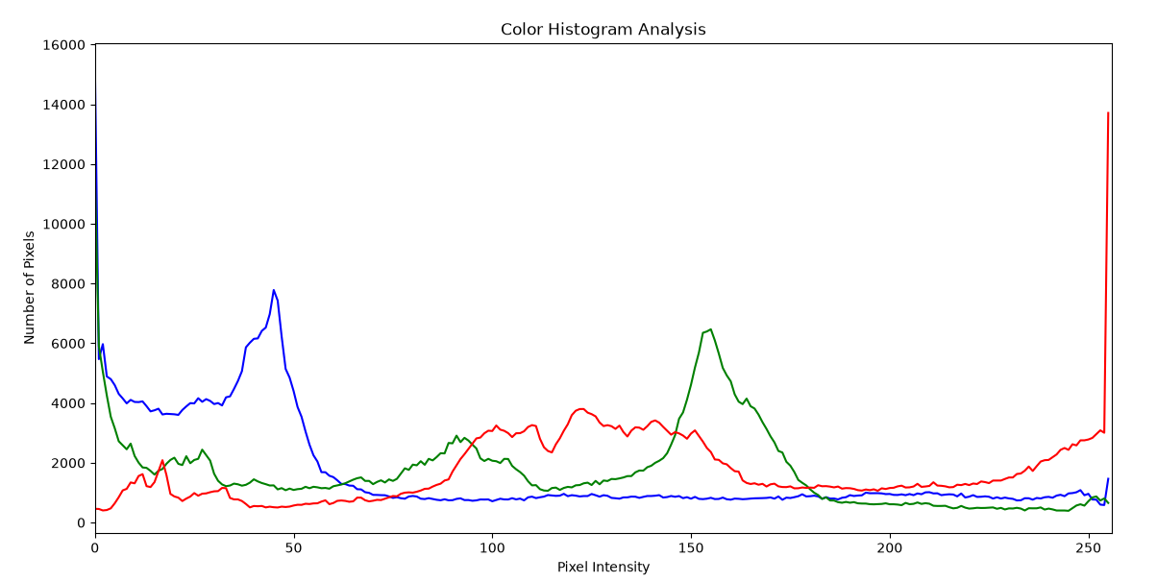
Result: The Python function for analyzing color level histograms was successfully implemented and executed using OpenCV.

